**2017 TMTA Conference Hotels**

**Hampton Inn**; 5575 Skyhawk Parkway; Martin, Tennessee 38237  
**731-587-5800 Use Rate Code : TMTA**  
Conference Rate - $91.00 + taxes   
Block of 30 rooms held until September 1, 2017   
Suite Rate - $124.00 - $144.00 + taxes

**Days Inn**; 800 University Street; Martin, Tennessee 38237  
**731-587-9577 Use Rate Code : TMTA**  
Conference Rate - $69.99 + taxes  
Block of 30+ rooms held until September 1, 2017

**Econo Lodge**; 853 University Street; Martin, Tennessee 38237  
**731-587-4241 Use Rate Code : TMTA**  
Conference Rate – $60.00 + taxes  
Block of 30+ rooms held until September 1, 2017  
  
**Hospitality House**; 1221 West Reelfoot Avenue; Union City, Tennessee 38261  
**731-885-6610 Use Rate Code : TMTA/UTM**  
Conference Rate - $52.00 + taxes  
Block of 25 rooms held until September 1, 2017

**Country Hearth Inn**; 2009 West Reelfoot Avenue; Union City, Tennessee 38261  
**731-885-7774 Use Rate Code : TMTA**  
Conference Rate - $ 69.99 + taxes  
Block of 15 rooms

**Quality Inn**; 2201 West Reelfoot Avenue; Union City, Tennessee 38261   
**731-885-8850 Use Rate Code : TMTA**Conference Rate - $ 91.00 + taxes  
Block of 30+ rooms held until September 1, 2017

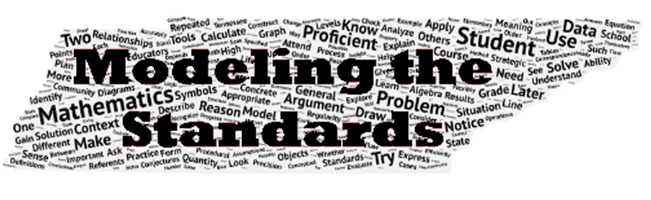ampHam